Sri Sri University

Project - Low Level Design

On

Customer Behavior Analysis

Team members:

M.S.L.V. Saranya

Aditya Narayan Panda

Sonali Nanda

Bhandari Sree Shivani

Guided by: Dr. Chinmaya Kumar Nayak

Industry Mentor:

Sumit Shukla

Table of Contents

1. Introduction 3
   1. Scope of the document 3
   2. Intended Audience 3
   3. System Overview 3
2. Low Level Design 4
   1. Sequence Diagram 4
   2. Navigation 4-5
3. Data Design 6

**Introduction**

* 1. Scope of the document

This document contains Low Level Design of the project Customer Behavior Analysis. It also covers the data design of the dataset being used for making the dashboards.

* 1. Intended Audience

The document is intended for team members of the project, faculty supervisor and industry mentor for the purpose of tracking and reviewing the progress.

* 1. System Overview

Customer Behavior Analysis is a project intended to help businesses understand their customers better. It creates dashboards based on customer data which gives valuable insights in the form of graphical method for easier understanding. The project comprises of a frontend made with SvelteKIT, backend using Django, and sqlite3 database. The dataset used for the project consists 5 lakh customer data points which will be used to create two types of dashboards:

1. Individual Dashboard: Dashboard for individual customers
2. Grouped Dashboard: Dashboard based on any attribute and its value

**Low Level Design**

2.1. Systematic Diagram

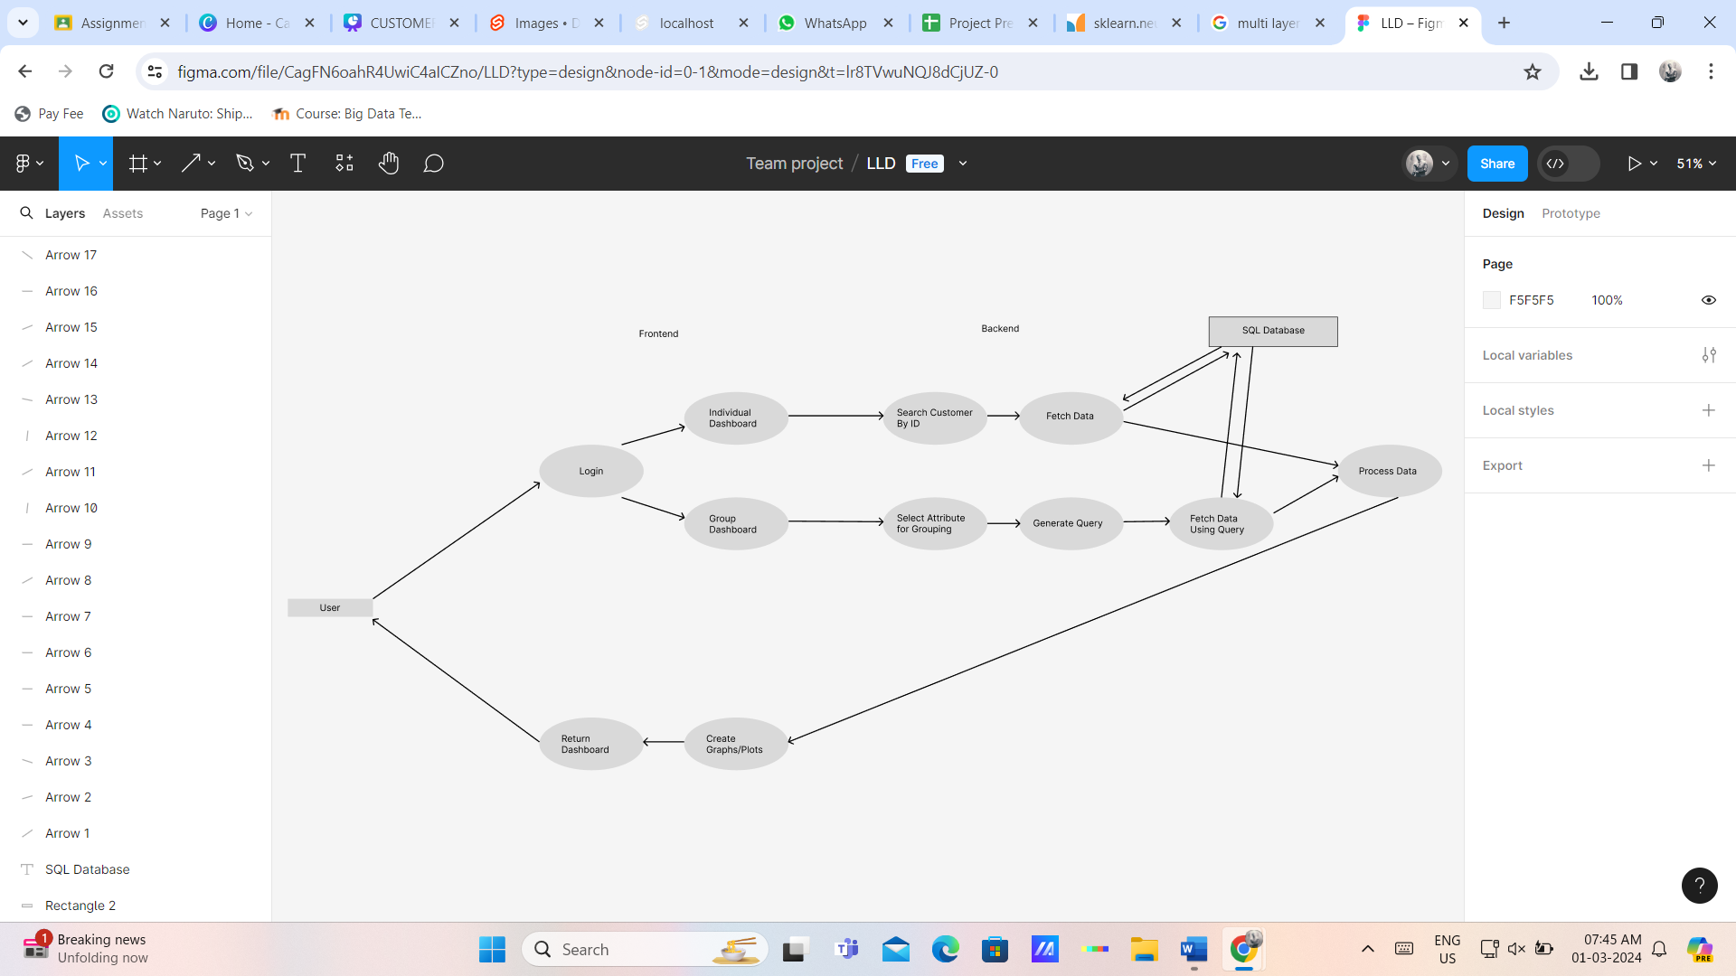

2.2. Navigation

Home Page

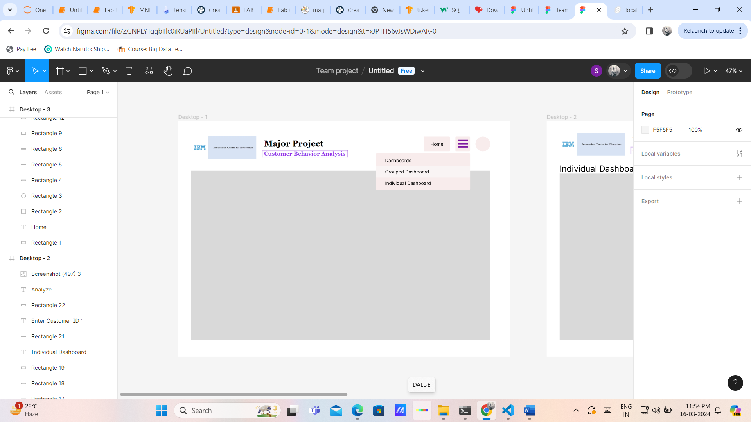

Menu:

1. Individual Dashboard

Navigates to a form asking Customer ID.

Click Analyze – Navigates to the Customers Dashboard

1. Grouped Dashboard

Navigates to a form asking Attribute and its Value to group data.

Click Analyze – Navigates to the Dashboard of all data points belonging to the group

**Data Design**

Schema: Django models.py

Database: db.sqlite3

No. of Tables: 1

Table Name: Customer

Attributes:

|  |  |  |  |
| --- | --- | --- | --- |
| Attribute Name | Data Type | Key Constraints | Max - Length |
| id | Integer | Primary Key |  |
| Cid | Integer |  |  |
| P_Date | Date-Time |  |  |
| Category | Char |  | 64 |
| Price | Float |  |  |
| Quantity | Integer |  |  |
| TPAmt | Float |  |  |
| Payment | Char |  | 64 |
| Returns | Float |  |  |
| Name | Char |  | 128 |
| Age | Integer |  |  |
| Gender | Char |  | 8 |
| Churn | Integer |  |  |